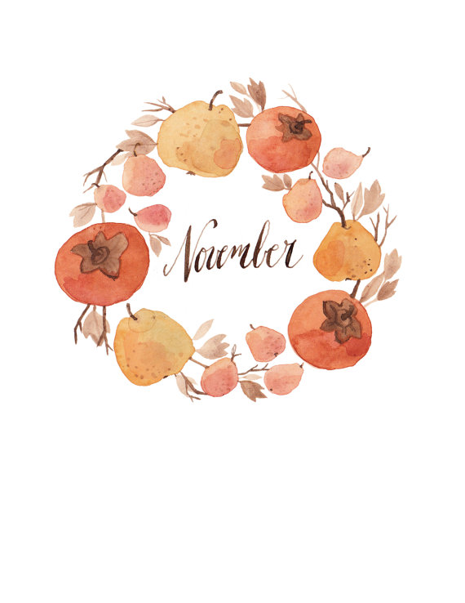

7 2 Corinthians 1:3-4 21 James 1:26-27
8 Philippians 4:6-9 22 James 2:1-4
9 Psalm 42: 1-6 23 James 2:5-7
10 Psalm 42: 7-11 24 James 2:8-11
11 Psalm 63: 1-6 25 James 2:12-13
12 Psalm 63: 7-11 26 James 2:14-17
13 Jerimiah 29:11 27 James 2:18-19
14 James 1:1 28 James 2:20-24
15 James 1: 2-8 29 James 2:25-26
16 James 1:9-11 30 Philippians 2:3-4
17 James 1:12-15
18 James 1:16-18
19 James 1:19-21
20 James 1: 22-25 Use the hashtag: #LWFPLAN

