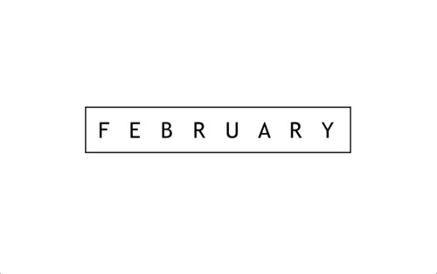

1 1 Corinthians 13:4-7 19 1 Peter 4:8
2 Romans 13:8-10 20 Romans 12:9
3 John 15:13 21 1 John 4:18
4 1 John 3:16-18 22 1 Corinthians 16:14
5 Romans 8:35-39 23 Mark 12:30
6 Romans 5:8 24 1 John 4:7
7 James 1:1-8 25 John 3:17
8 Psalm 136:1-26 26 1 John 4:19
9 Mark 12:31 27 1 Corinthians 13:13
` 10 Song of Solomon 8:6-7 28 Mathew 5:43-48
11 John 14:23
12 Galatians 5:22-23
13 1 Corinthians 13:1-13 #LWFPLAN
14 1 John 4:10 Post a picture with the hashtag!
15 Mathew 7:7
16 1 Corinthians 13:1-7
17 1 Corinthians 13:8
18 John 3:16

